Trend Application Deployment
GUVI Project 2
Trend runs on port 3000 in Amazon EKS. Jenkins builds and tests the Nginx image, publishes it to Docker Hub, and deploys it to Kubernetes. Prometheus checks the public health endpoint every 30 seconds.
Source repository on GitHub
Trend application on port 3000
Trend image tags on Docker Hub

Network Load Balancer ARN
arn:aws:elasticloadbalancing:ap-south-1:680391390182:loadbalancer/net/
k8s-trend-trend-6bf4b2f0cb/5344529484c66e9e
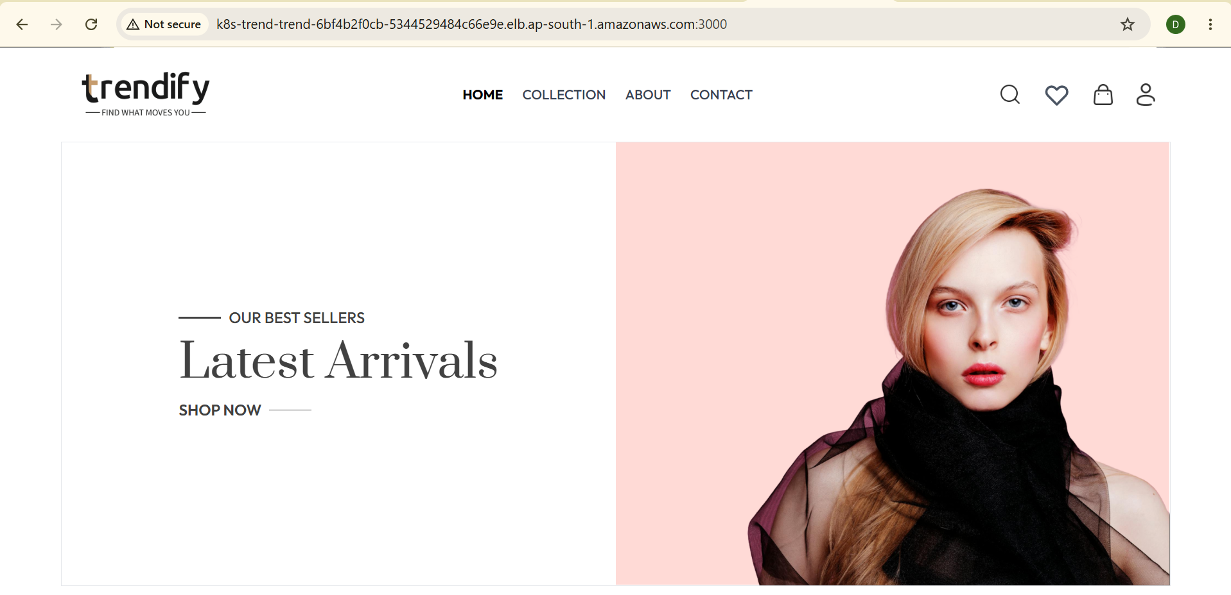
Figure 1. Trend served through the AWS Network Load Balancer.

Local Docker Verification
The upstream repository supplies the compiled website in dist/. The Dockerfile copies those files into Nginx and configures port 3000. The local smoke test checked the homepage and the /healthz endpoint before image publication.
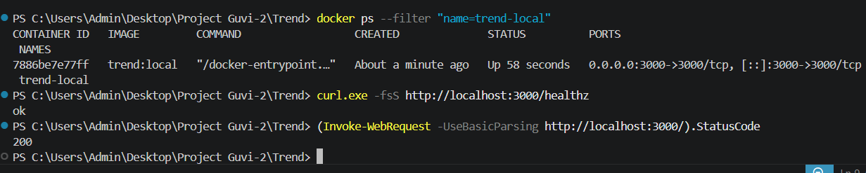
Figure 2. Docker mapped port 3000, the health check returned ok, and the homepage returned HTTP 200.

Figure 3. Trend loaded locally on port 3000.

AWS Infrastructure and EKS
Terraform provisioned the VPC, public and private subnets, IAM roles, Jenkins EC2 instance, and EKS Auto Mode cluster in ap-south-1. The trend namespace contains the application Deployment and LoadBalancer Service.
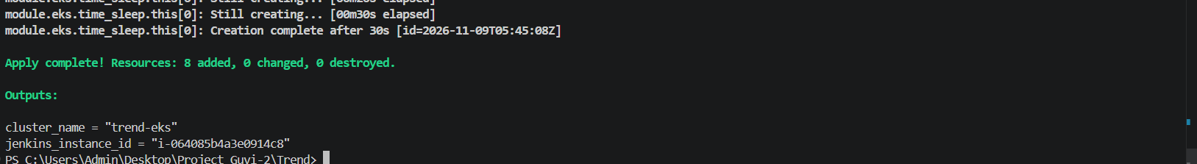
Figure 4. Terraform reported a successful apply for trend-eks.
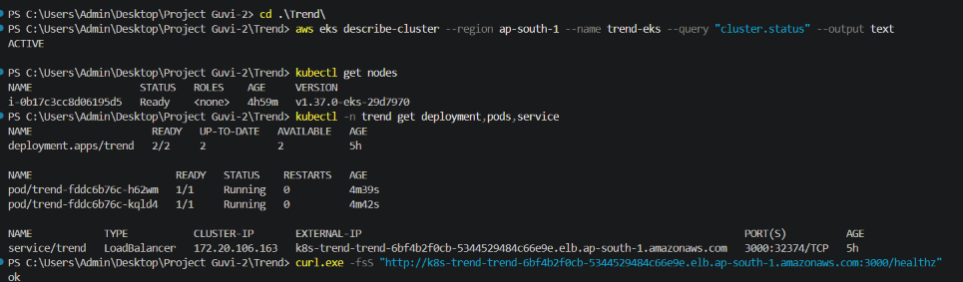
Figure 5. EKS was ACTIVE, the worker node was Ready, and both application replicas were available.

Jenkins and GitHub Webhook
The trend-deploy job reads the declarative Jenkinsfile from main. It builds and smoke-tests the image, pushes a commit-tagged image to Docker Hub, applies the Kubernetes manifests, waits for the rollout, and checks /healthz. GitHub sends signed push events through Tailscale Funnel to a relay on the Jenkins EC2 instance.
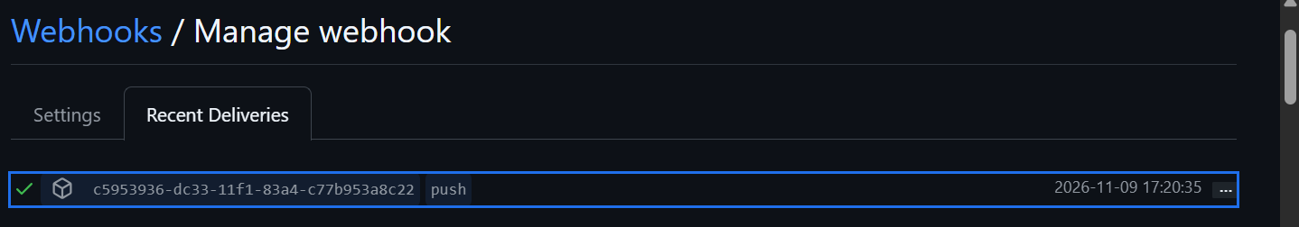
Figure 6. GitHub recorded an HTTP 200 response for a push delivery.
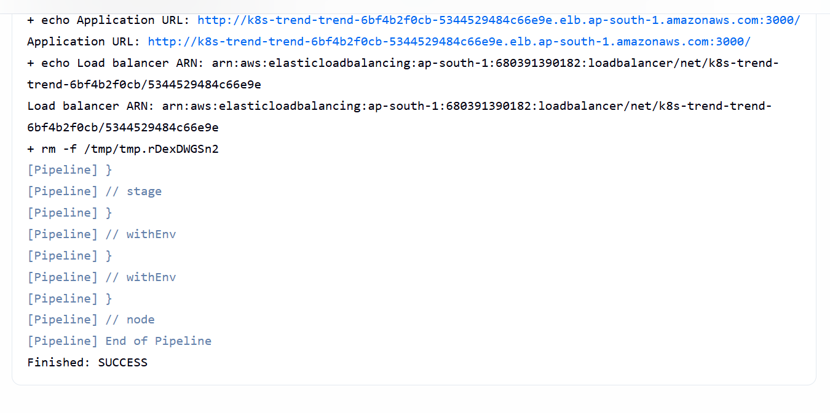
Figure 7. Jenkins reported SUCCESS and printed the application URL and load balancer ARN.

Continuous Application Monitoring
Prometheus scrapes Blackbox Exporter every 30 seconds. The exporter makes an HTTP request to /healthz through the public load balancer. A probe_success value of 1 means the probe passed. The Prometheus interface is accessible through AWS Systems Manager port forwarding.
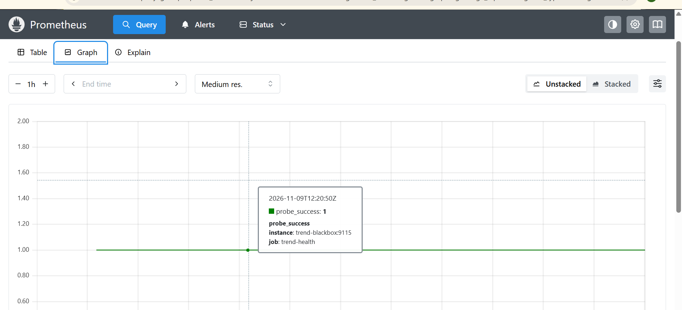
Figure 8. Prometheus showed a successful Trend availability probe.

